NSS CELLReport, Bengtol College

Prepared by_
Dr. Anosh Narzary, NSS Programme Officer

- Report on Observation of World Environment Day
Organized by NSS Unit, Bengtol College
Date: 5th June 2025
Venue: Gwbwrki Bazar
The NSS Unit of Bengtol College observed World Environment Day on 5th June 2025 at Gwbwrki Bazar in collaboration with the NSS Unit of Runikhata College and the Environmental and Forest Department of Khungring. The programme aimed to promote environmental protection, tree plantation, and awareness about sustainable living among the local community and students.
During the programme, around 300 saplings were planted in and around the Gwbwrki Bazar field by NSS volunteers, college staff, and local residents. The plantation drive was followed by an educational awareness campaign highlighting the importance of afforestation, waste management, and conservation of natural resources. The event inspired participants to take active roles in protecting the environment.
In the afternoon session, a friendly football competition was also organized to promote unity, teamwork, and youth engagement in community activities. The event attracted enthusiastic participation and added a spirit of joy and togetherness to the day’s activities.
The programme concluded successfully with a pledge to continue such eco-friendly initiatives in the future. The collaborative effort of the two colleges and the Forest Department made the event both impactful and memorable.
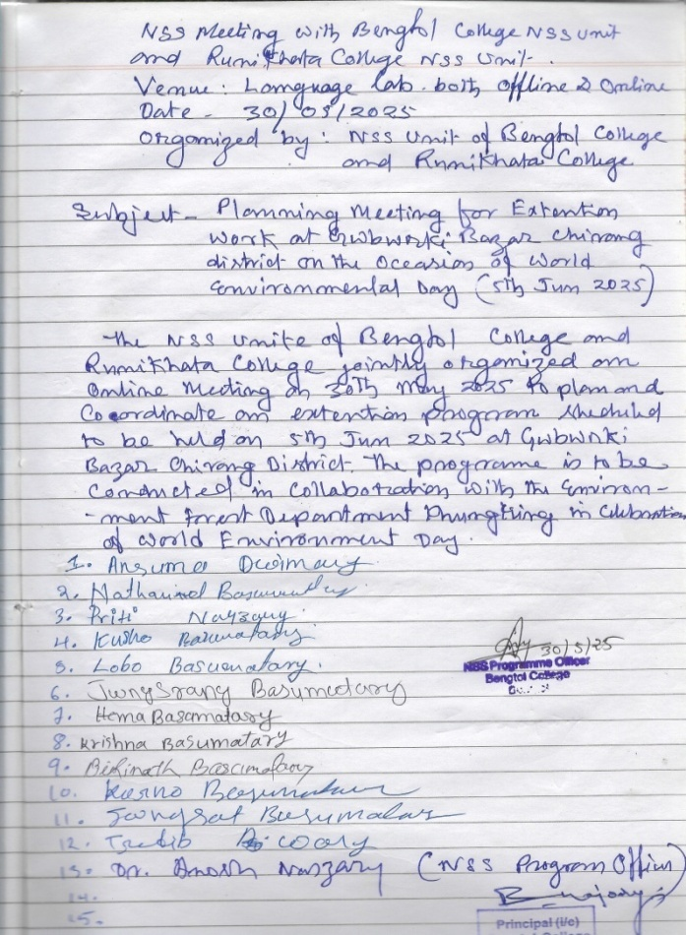
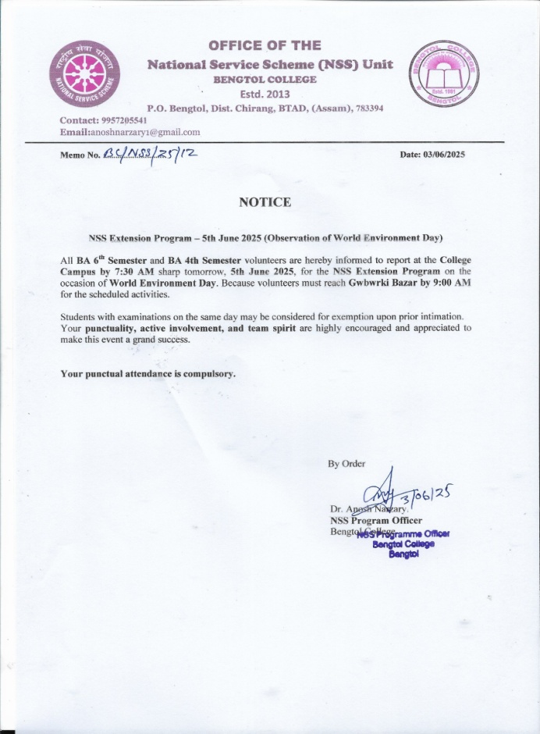

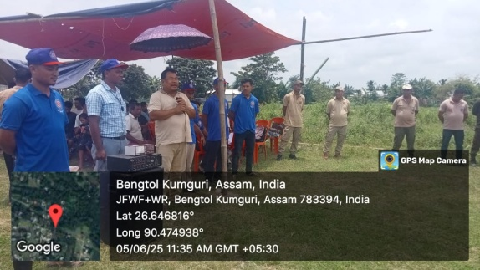
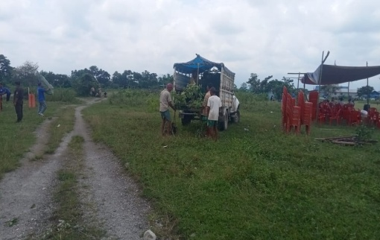
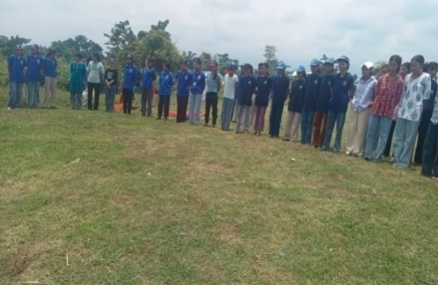

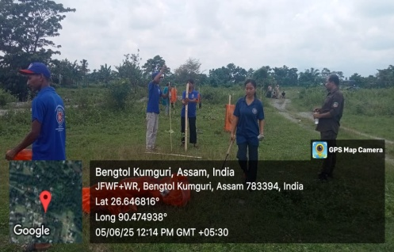
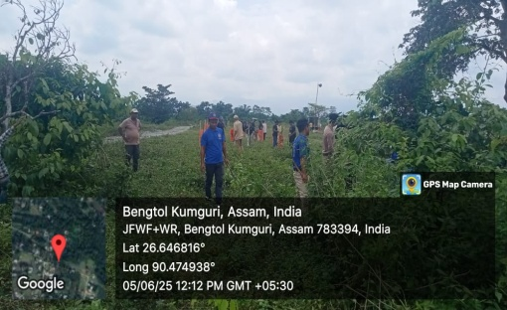
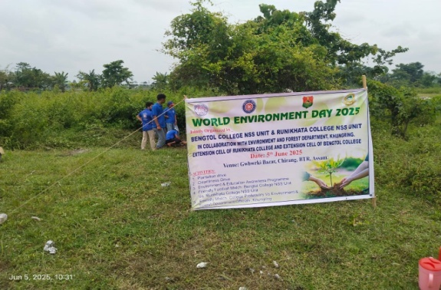

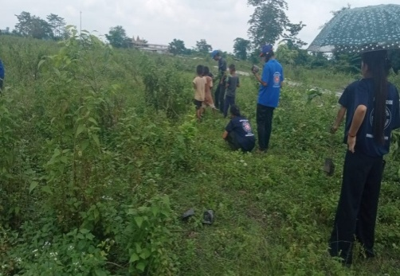
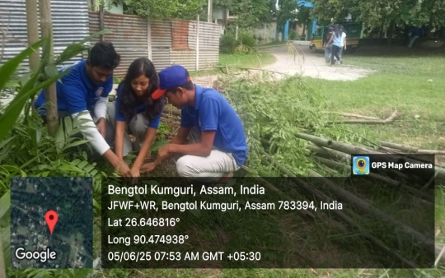
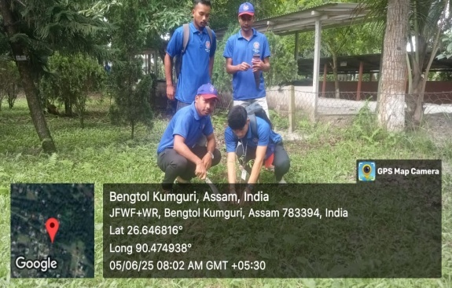
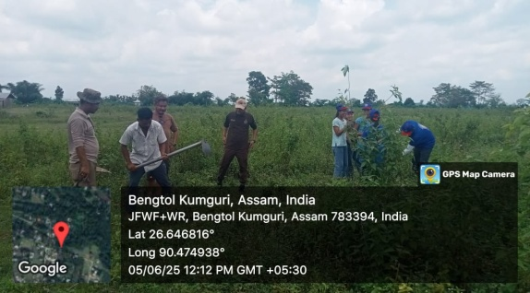

- Report on Special Camp of NSS, Bengtol College
Date: 08/05/2025 to 12/05/2025
Organized by: NSS Unit, Bengtol College
Venue: Anthaibari and Aienodichor Villages, Chirang District, Assam
The National Service Scheme (NSS) Unit of Bengtol College organized a Special Camp from 8th May to 12th May 2025 at Anthaibari and Aienodichor Villages under Chirang District. The camp aimed to create social awareness and promote rural development through a series of community-based programmes focusing on education awareness, cleanliness, health, and environmental conservation in the adopted villages.
During the camp, several activities were conducted with enthusiastic participation from NSS volunteers, villagers, students, and local leaders. The Education Awareness Programme emphasized the importance of education, literacy, and regular school attendance. A Guardian Meeting was held at the LP School, Aienodichor, where parents and teachers discussed the need for mutual cooperation to improve students’ performance and discipline.
The NSS volunteers also organized Cleanliness Drives in both Anthaibari and Aienodichor villages. Public places, school compounds, and village roads were cleaned under the slogan “Clean Village, Healthy Village.” The activity encouraged villagers to maintain cleanliness and sanitation in their surroundings.
A Health Awareness Programme was conducted to educate villagers about hygiene, sanitation, and preventive healthcare. As part of the camp’s environmental initiative, a Plantation Drive was carried out in both villages. The NSS volunteers planted a variety of saplings in school premises, roadside areas, and community spaces, promoting the message of “Plant Trees, Save Earth.”
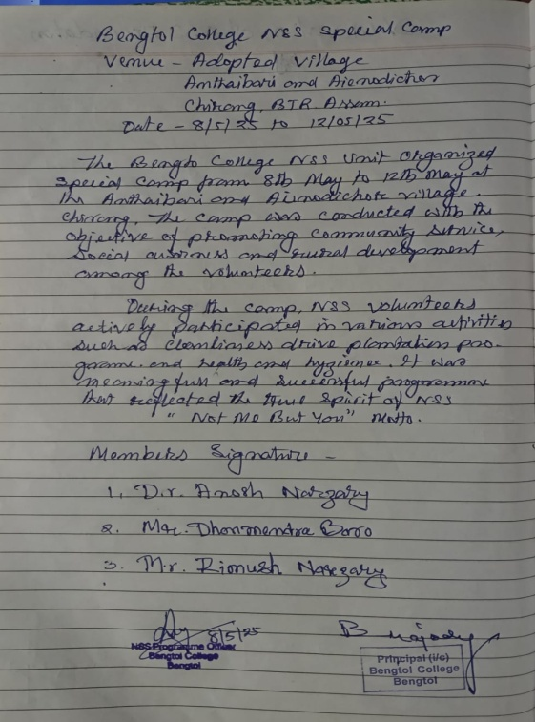
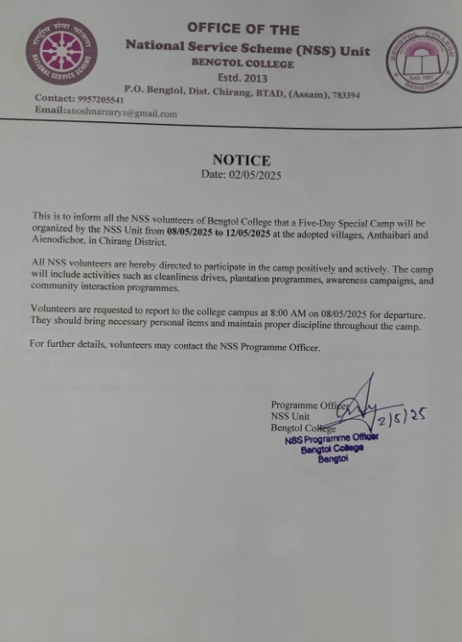
The camp concluded on 12th May 2025 with a community meeting where villagers expressed appreciation for the efforts of Bengtol College NSS Unit. The Programme Officer assured continuous engagement and support for the development of the adopted villages.

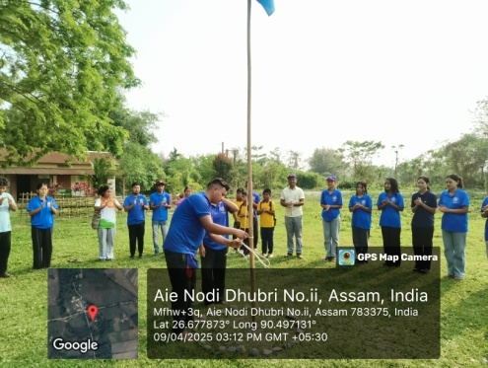
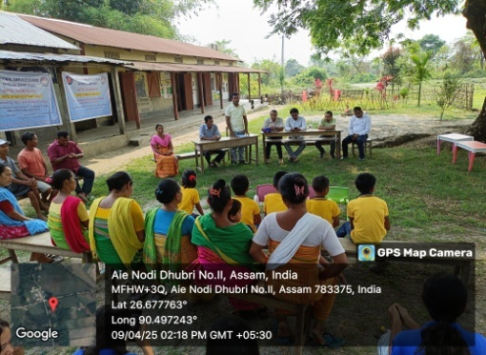
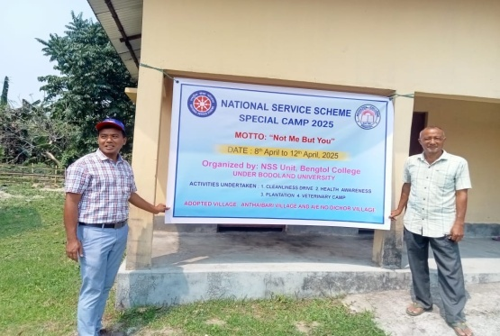
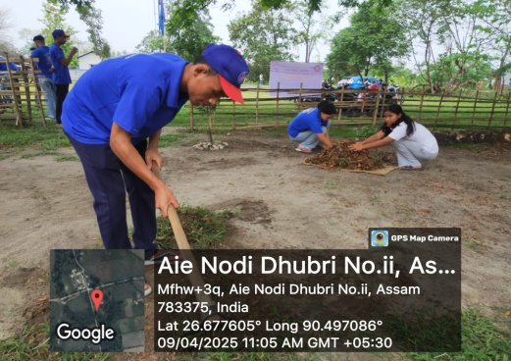
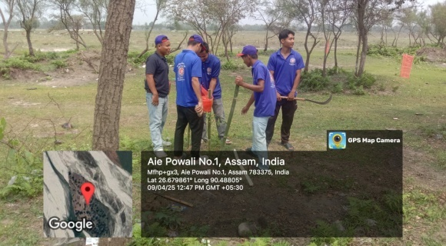
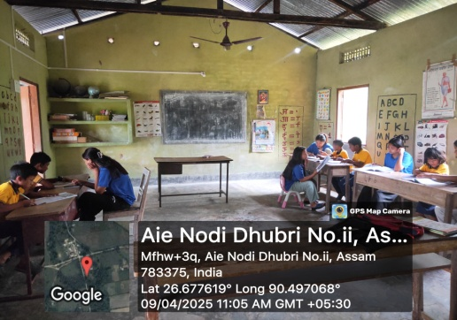
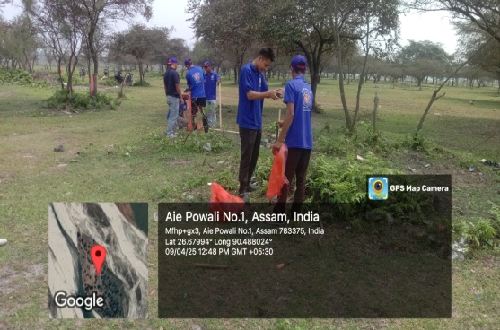
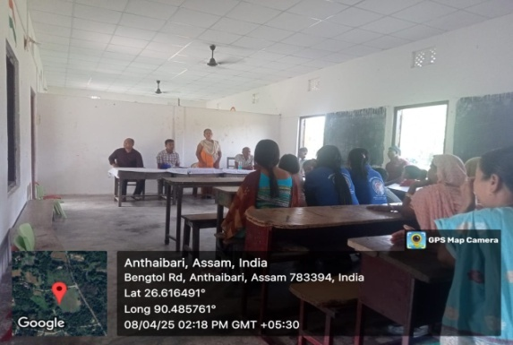
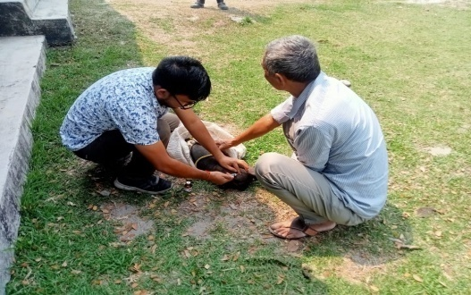

- Report on International Yoga Day Celebration
Date: 21st June 2025
Organized by: NSS Unit, Bengtol College
In Collaboration with: IQAC, Bengtol College
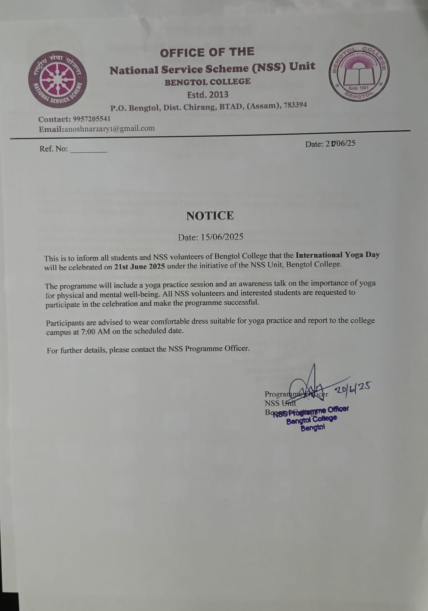
The NSS Unit of Bengtol College, in collaboration with the Internal Quality Assurance Cell (IQAC), observed International Yoga Day on 21st June 2025 in the college campus. The programme aimed to promote physical, mental, and spiritual well-being among students and staff through the practice of yoga.

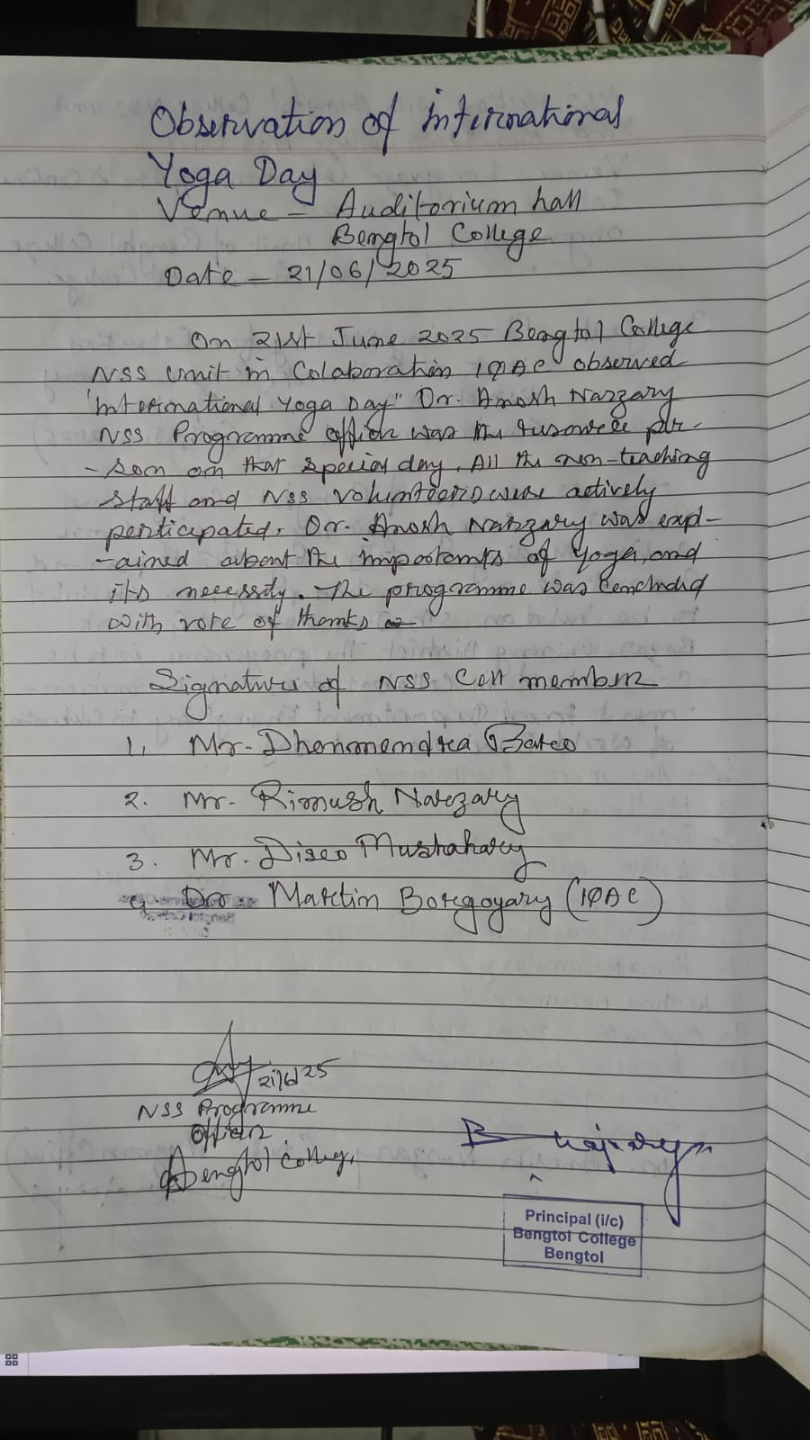

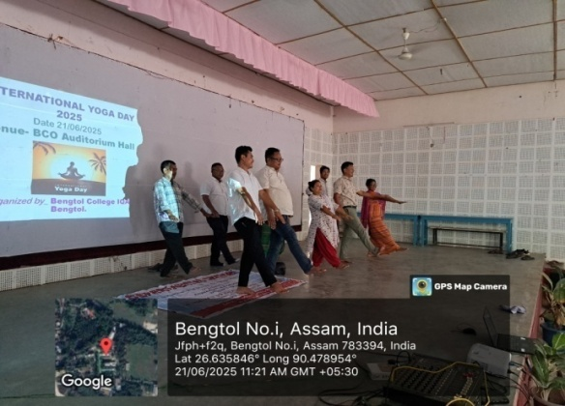
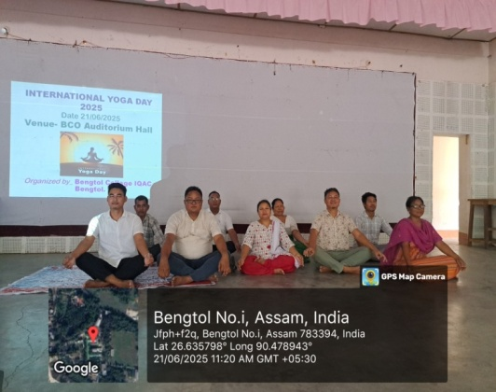
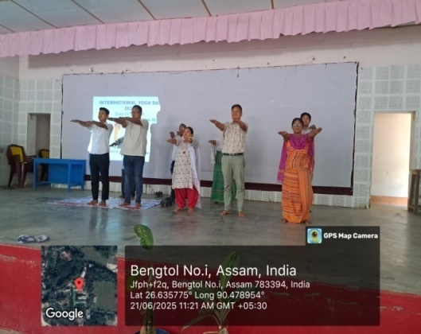

- Awareness Programme on Gutkha, Tobacco, and Cancer
Date: 17/05/2025
Venue: College Auditorium
Resource Person: Dr. Taska Ulupi, Assam Cancer Care, Chirang
An Awareness Programme on the harmful effects of gutkha, tobacco, and their direct link to cancer was organized on 17th May 2025 at the College Auditorium. The programme aimed to educate students about the severe health risks associated with the consumption of tobacco and tobacco-related products, which continue to be major causes of oral and lung cancer in India.
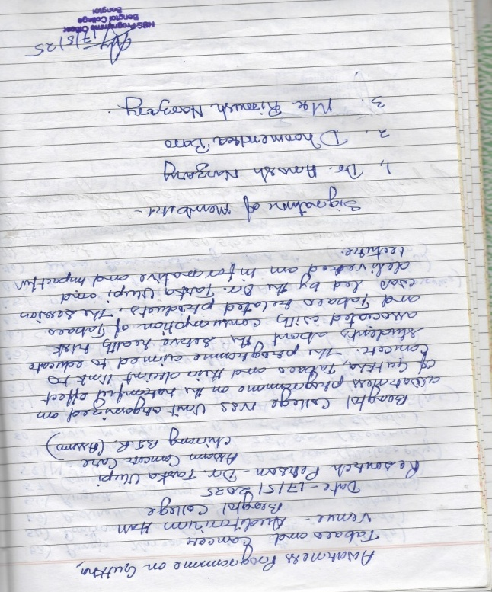
The session was led by Dr. Taska Ulupi from Assam Cancer Care, Chirang, who delivered an informative and impactful lecture. Dr. Ulupi explained the chemical composition of gutkha and tobacco, highlighting carcinogenic substances that contribute to various forms of cancer. She emphasized the rising number of cancer cases in Assam and urged students to avoid all forms of tobacco use.
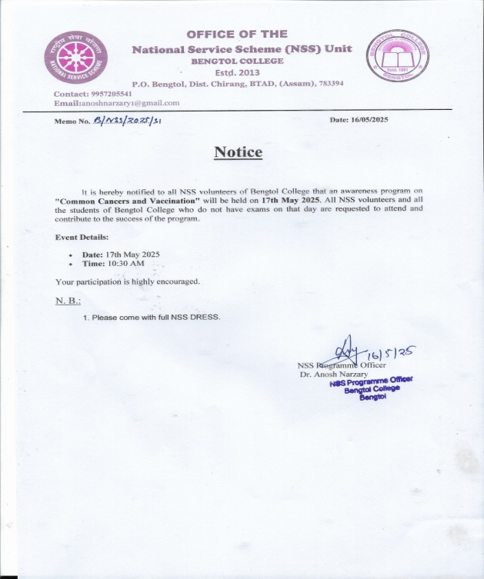

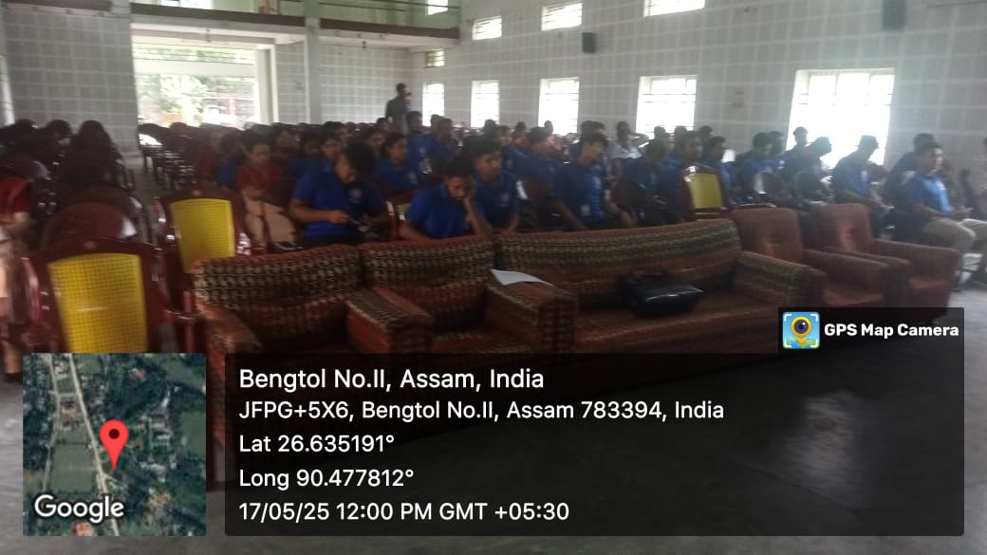
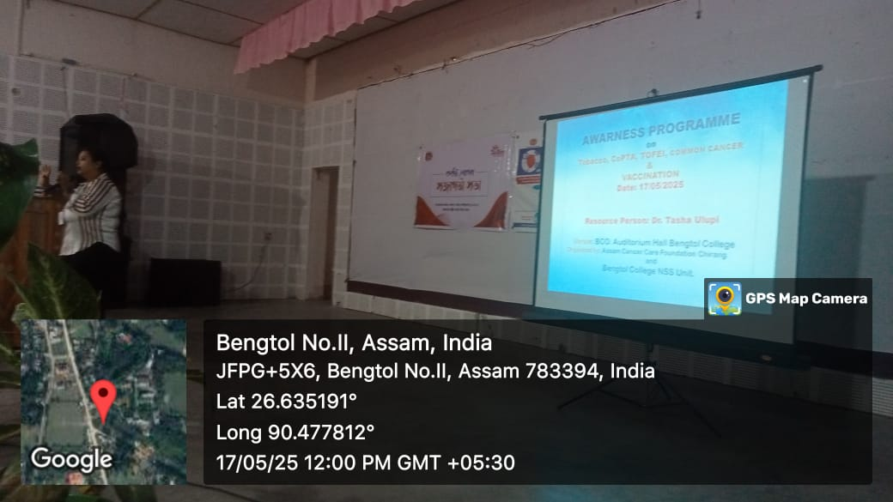

- On 24 September 2024, the NSS Unit of Bengtol College Observed NSS Foundation Day at in front of the NSS Office Bengtol College
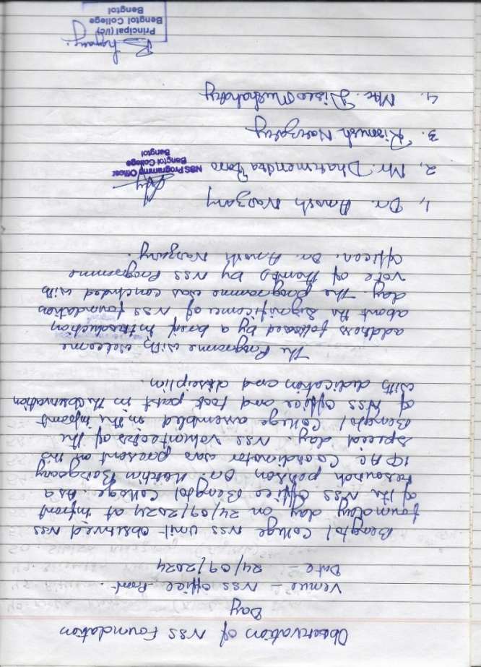
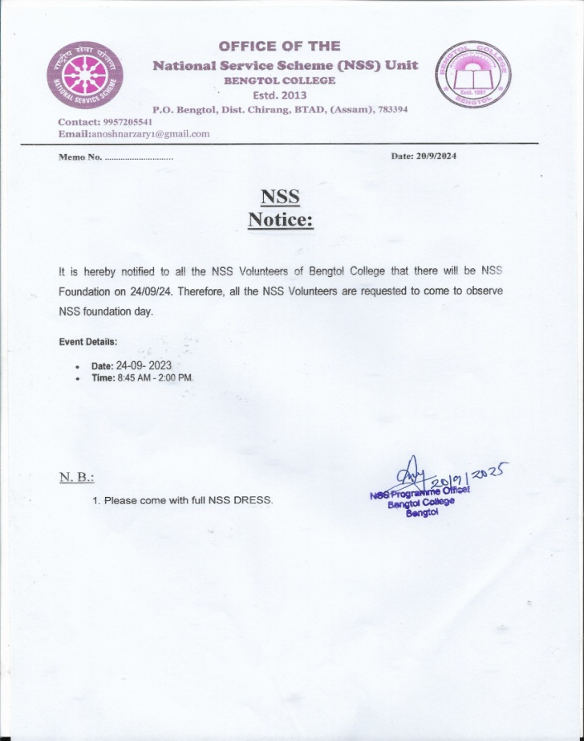

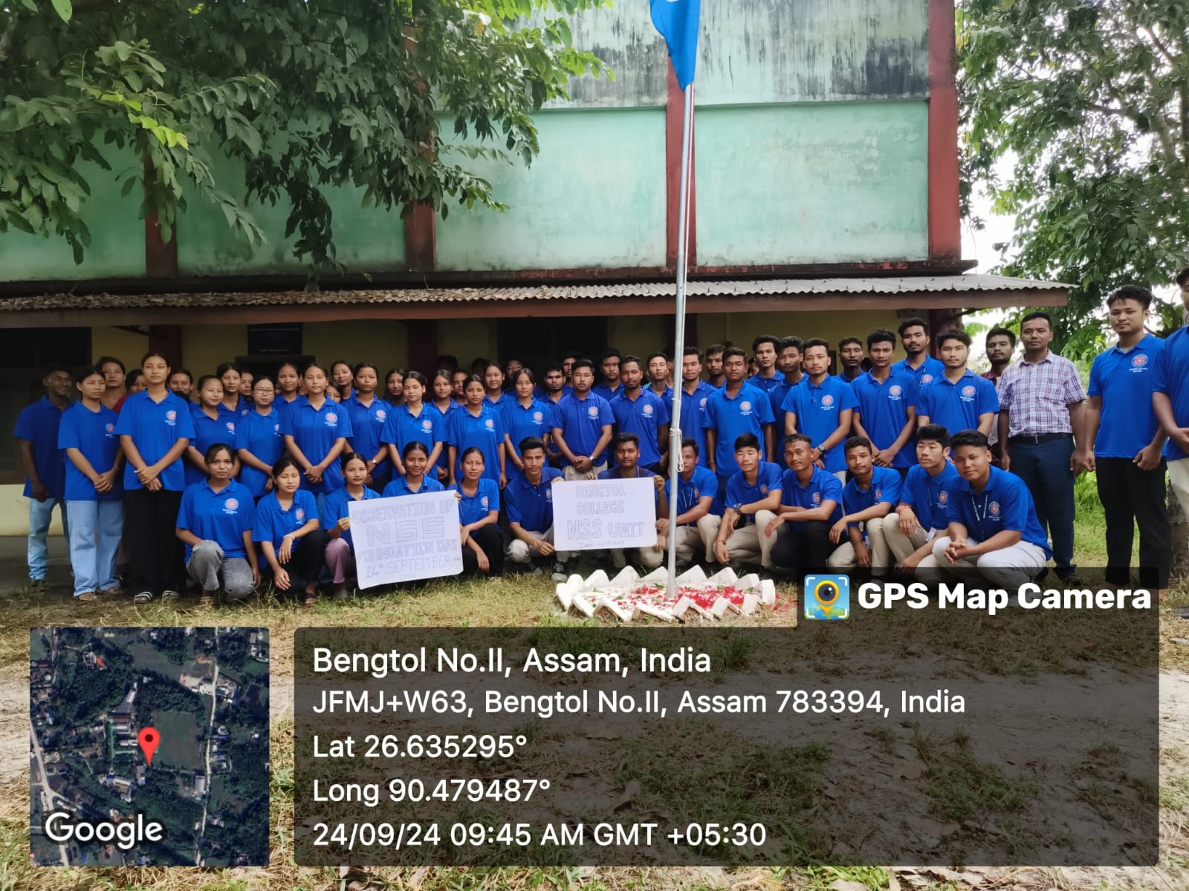

- On 04 September 2024, the NSS Unit of Bengtol College conducted a Campus Cleanliness Programme with active participation from NSS volunteers. The drive aimed to promote cleanliness, hygiene, and a healthy campus environment. Volunteers cleaned different areas of the college premises and spread awareness about maintaining a clean and green campus.
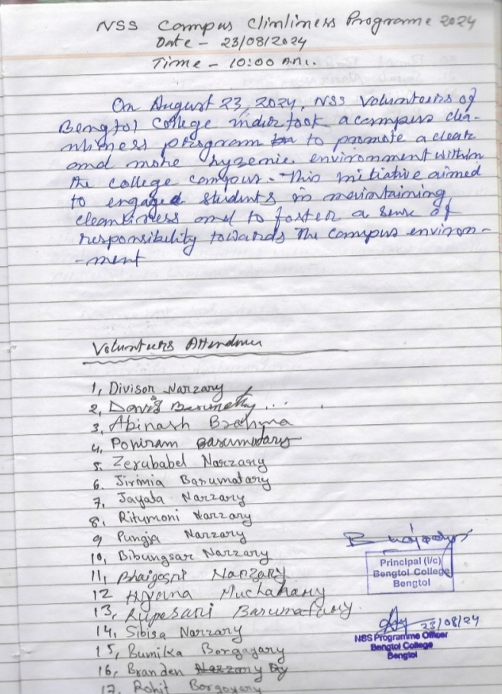
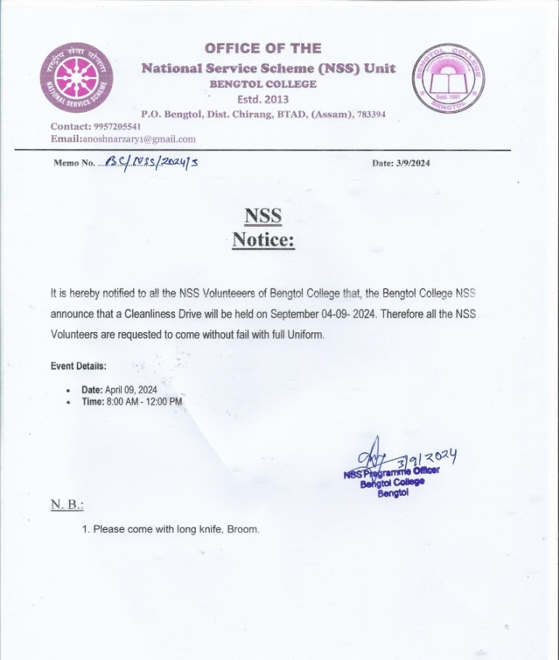

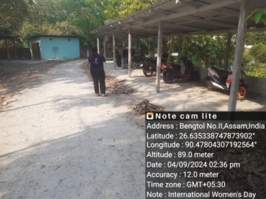
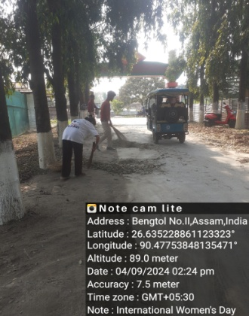
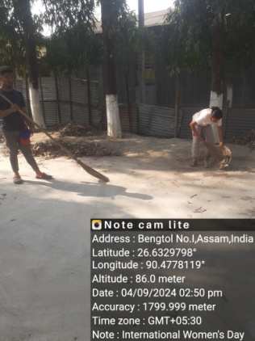
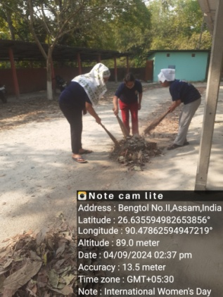
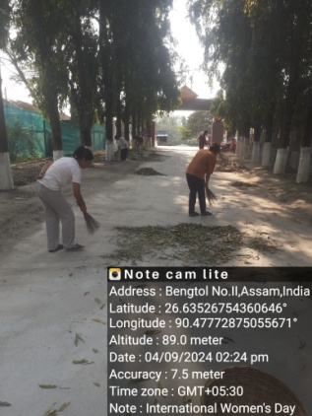

- Special Camp 26th August to 4th September 2024
The National Service Scheme (NSS) of Bengtol College has consistently worked towards community service, social welfare, and the empowerment of local communities. Throughout the year, NSS volunteers have actively participated in various activities both within the campus and in adopted villages, with the focus on rural development, education, and health.
This year, the NSS unit of Bengtol College organized a special camp from 26th August to 4th September 2024 in two adopted villages: Anthaibari and Aie Dubri. These villages were selected for their need for educational support, social upliftment, and economic development.
3. Activities Undertaken During Special cam:
- Economic Survey:
- Health and Hygiene Awareness:
- Community Development Activities:
- Environmental Awareness Programs:
- Educational Awareness:
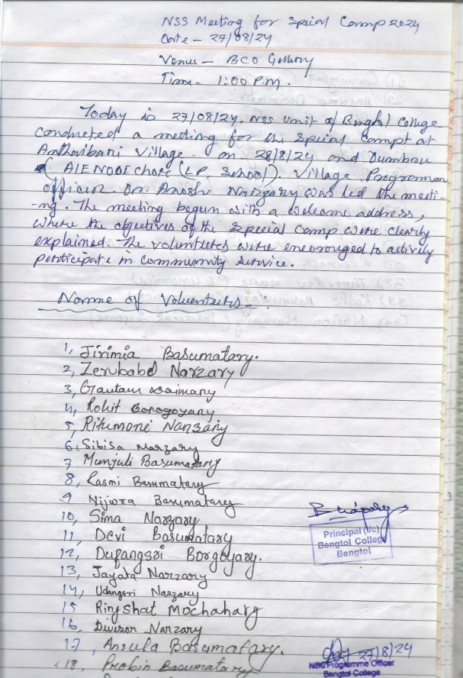
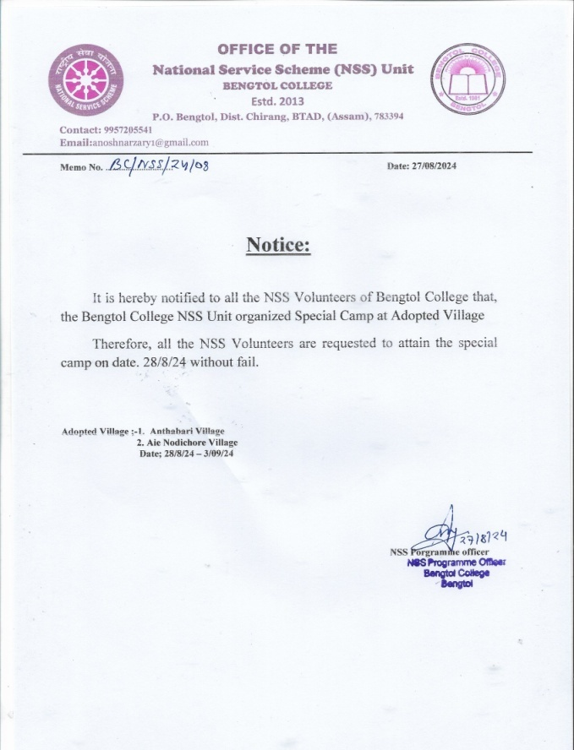

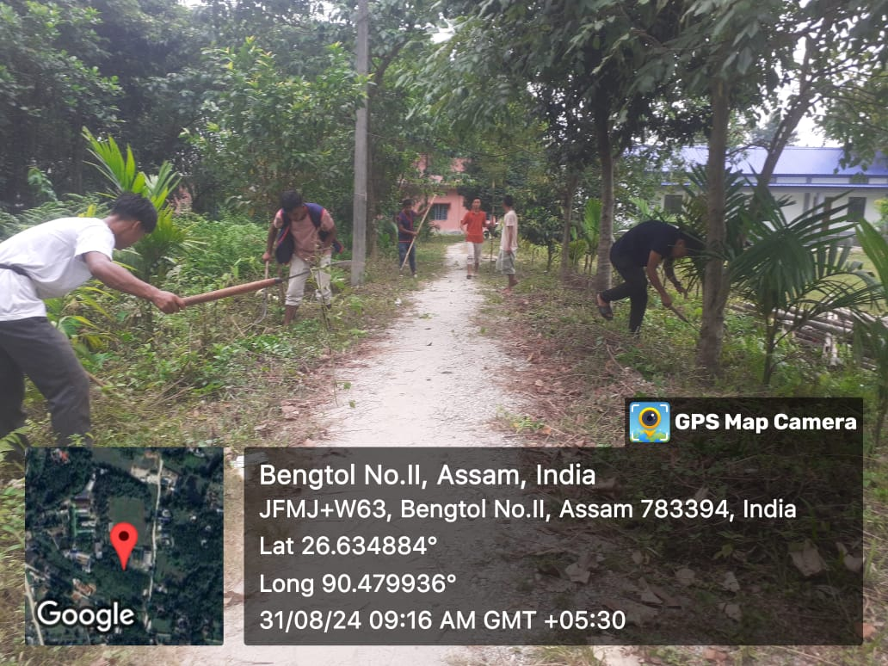
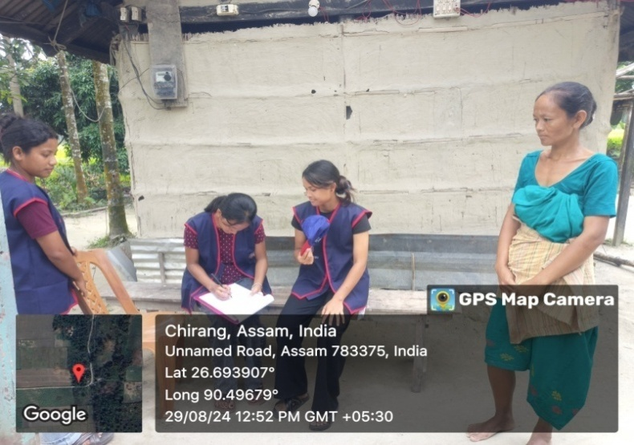
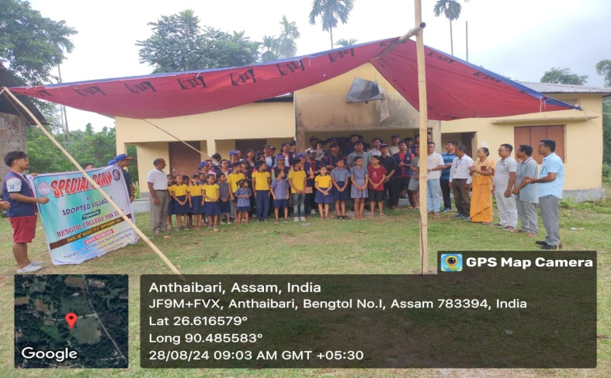
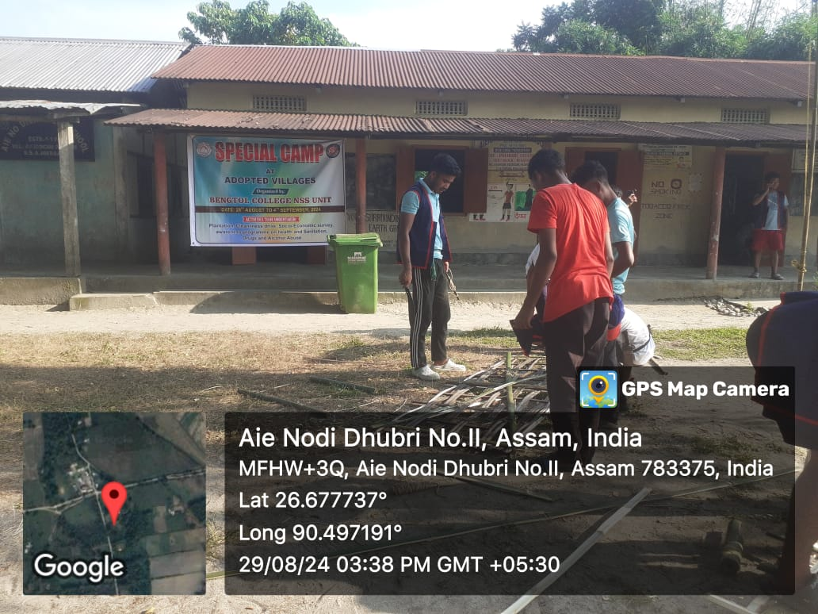
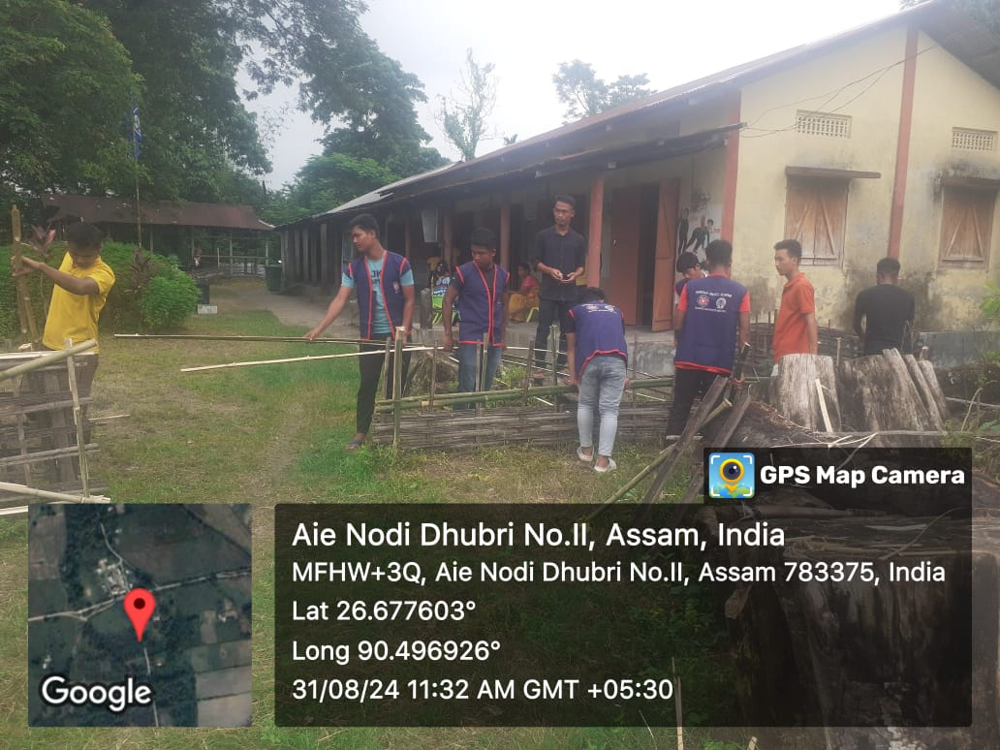
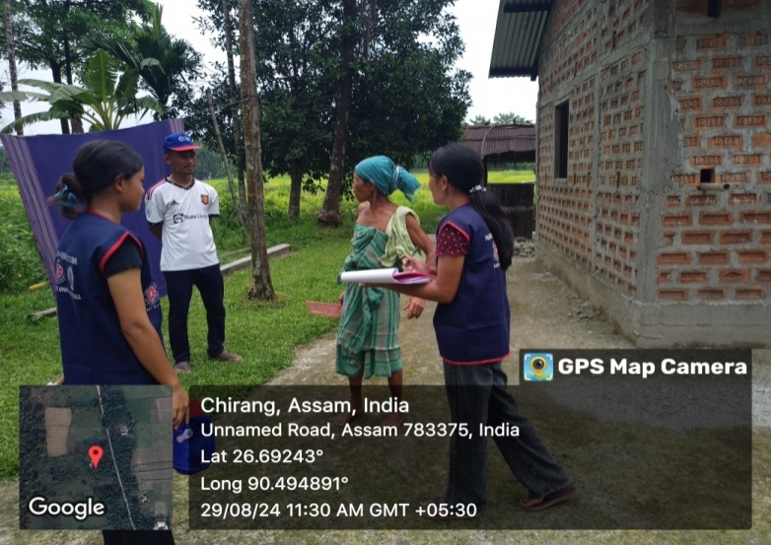

My Bharat Programme - 26/09/2024
Theme: Swachchata is Seva Hai 2024
Organized by: NSS Unit, Bengtol College

On September 26, 2024, the NSS Unit of Bengtol College successfully conducted a series of cleanliness initiatives under the theme "Swachchata hi Seva 2024," as directed by the Government of India. This program aimed to instill the value of cleanliness in our community and environment.

Activities Conducted:
- College Campus Cleanliness:
NSS Unit of Bengtol College organized a thorough cleanup programme of the college campus, including classrooms, gardens, and common areas. Students volunteers are participated enthusiastically, promoting a sense of ownership and pride in their surroundings.
- Public Road Cleanliness:
NSS members took to the streets, cleaning local roads and encouraging the publics
awareness banners were displayed to educate the public on maintaining cleanliness.
- Bengtol Primary Health Centre (PHC):
  - Surrounding of Bengtol PHC campus is also done the cleanliness drive, enhancing the health facility's environment. Informational banner on hygiene practices were displayed to patients and staff.
- Bengtol Primary Health Centre (PHC):
  - Surrounding of Bengtol PHC campus is also done the cleanliness drive, enhancing the health facility's environment. Informational banner on hygiene practices were displayed to patients and staff.

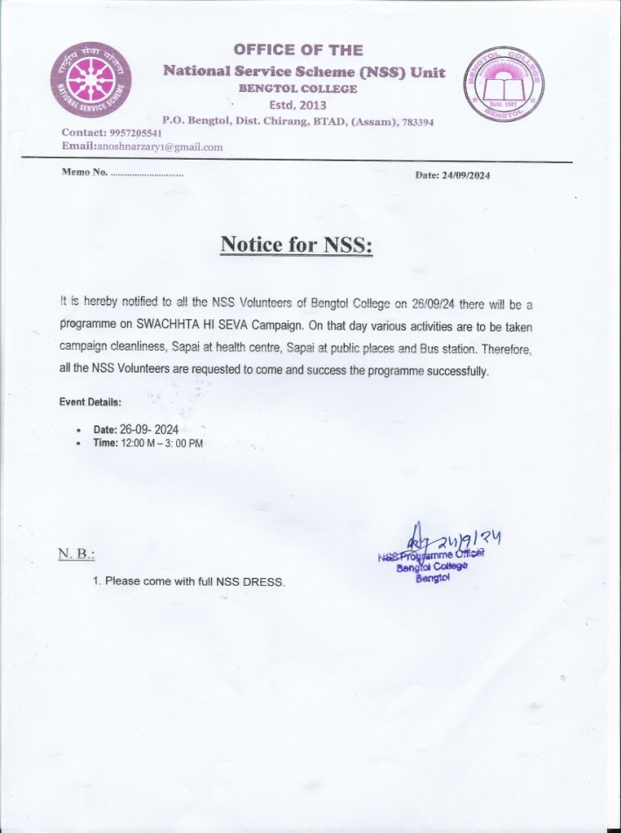
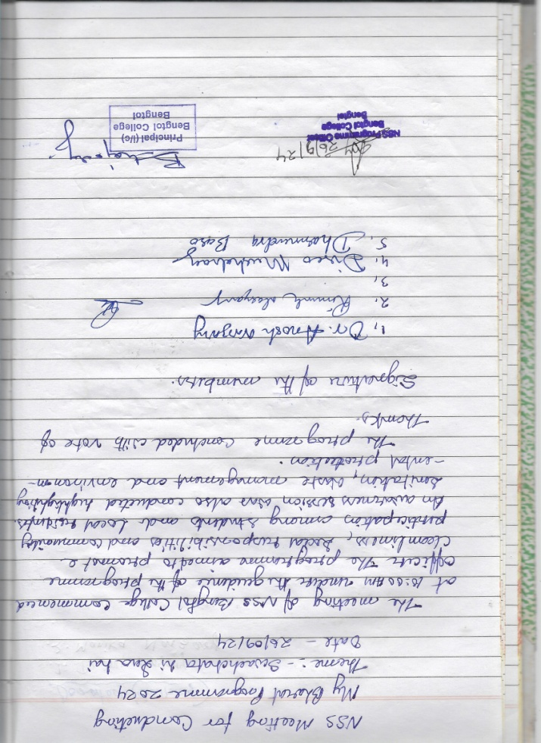

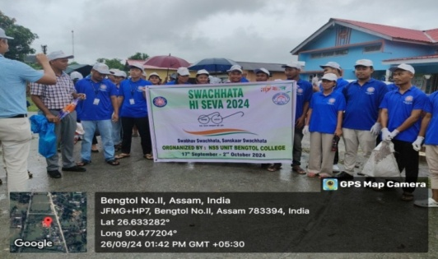
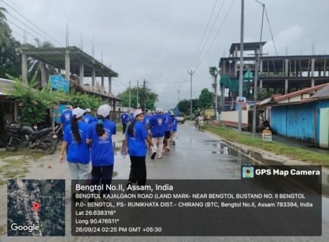
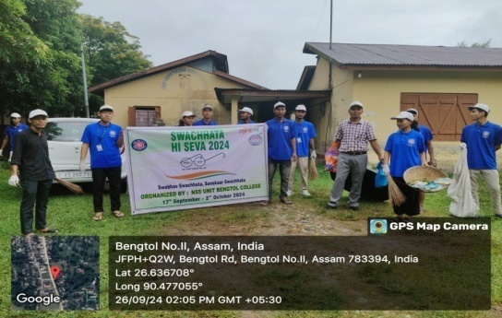
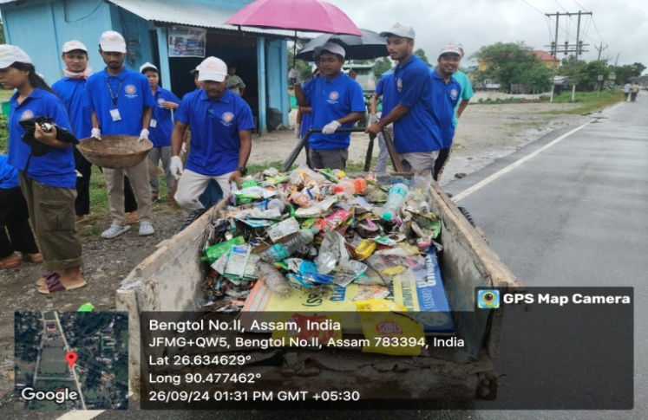
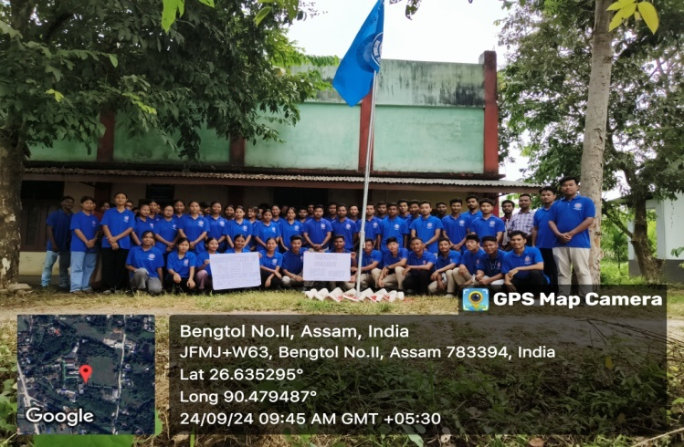

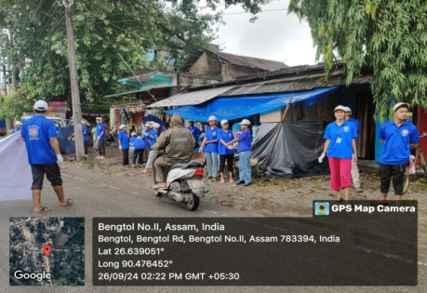
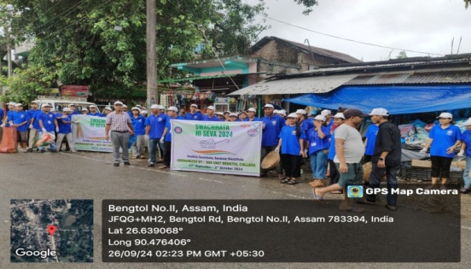

- Red Marathon Race and Free RD Camp at Bodoland University 2024.
On September 11, 2024, the NSS Unit of Bengtol College actively participated in the Red Marathon Race and Free RD Camp organised at Bodoland University. The programme aimed to promote health awareness, fitness, and community well-being among students and participants. The competition was fierce across all categories, showcasing a high level of athleticism and dedication from the runners. The NSS volunteers from Bengtol College made an outstanding impression in the Girls Marathon race.
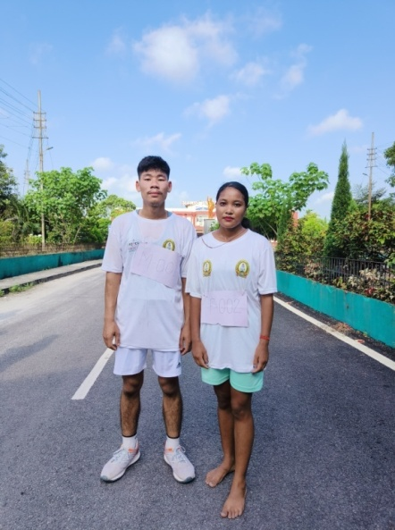
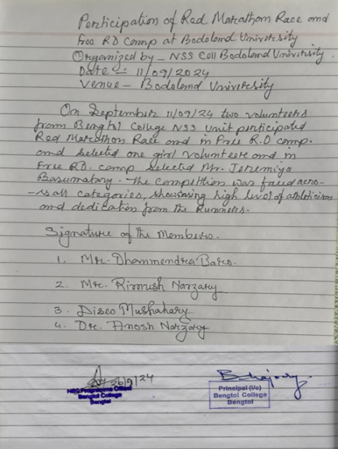
As a result of their victory, the Bengtol College NSS team has been selected to participate in the upcoming Republic Day parade, an honor that reflects their excellence and discipline.

